**ASSIGNMENT 10.4**

**Problem Statement:**

* Write a pig script find the average age of male and female persons died in the titanic tragedy.
* Write a pig script to find the number of people died and survived in each class.

**Input:**

Link to download the dataset

**Titanic_Data_Set**

**DATA SET DESCRIPTION:**

Column 1: PassengerId

Column 2: Survived (survived=0 & died=1)

Column 3: Pclass

Column 4: Name

Column 5: Sex

Column 6: Age

Column 7: SibSp

Column 8: Parch

Column 9: Ticket

Column 10: Fare

Column 11: Cabin

Column 12: Embarked

**Program:**

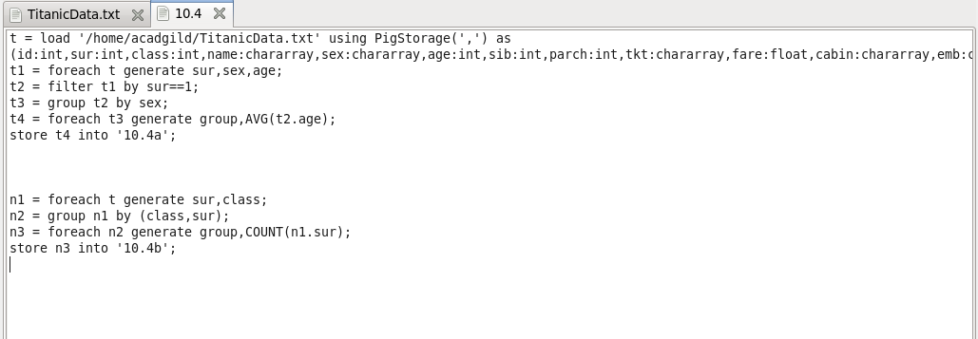

**OUTPUT:**

